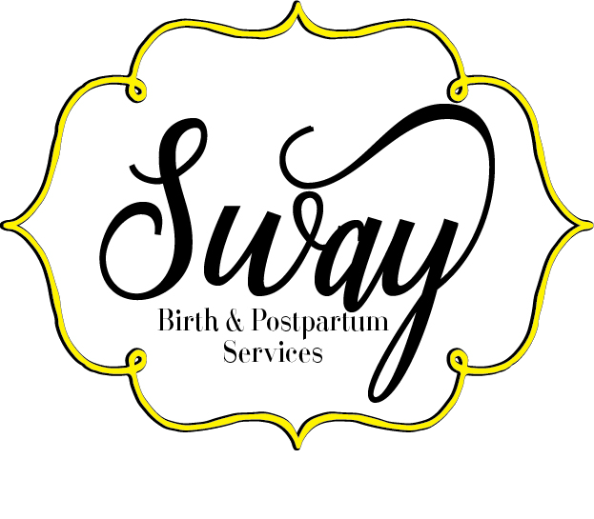

PLACENTA PREPARATION CONTRACT

SERVICES DESCRIPTION
Encapsulation Service includes:
• The Placenta(s) will be picked up and encapsulated at an agreed location.
• Full Placenta preparation package with any other requested services.
• Upon complete preparation, the Placenta will be properly stored in a container with pills.
• Suggestions for ingestion quantity and resources for more information on it will be provided.
• Timely delivery of finished placenta product to the client at the agreed location.
Your Placenta Specialist will ensure that the Placenta is properly cleaned and processed and precautions on ingestion of Placenta will be provided. It will be ensured that the highest quality of care is attained for proper storage and duration period.

1. Method of Preparation
□ - Raw
□ - Steamed

2. Capsule Preference
□ - Gelatin □ - Vegetable □ – Fruit flavored
□ – Small capsules
3. Location of Preparation
□ - Client's or family member's home
Address: _______________________________________________________________
□- S. W.’s Location

4. Additional Services
□ - Umbilical Cord Keepsake (included in base price)
□ - Heart □ - Letter/Initial □ - 'Love' □ Other
□ - Placenta Print $20
□ - Blood □ - Food coloring
□ - Placenta Tincture $20

--------------- Clients Initials

FEES AND SERVICES
The above outlined services are provided at a base fee of $225.
Locations out of reach of S. W. as listed below will attract an extra fee and this will only be for delivery of finished product.
- 25-40 miles (Jeannette, Butler, Export, Tarentum, Seven Fields) - $20
- 40-55 miles (Latrobe, Youngstown, Mt. Pleasant, Vanderbilt) - $40
- 55-70 miles (Morgantown, Blairsville, Wheeling)- $60
A down payment of $50 is required upon signing of this contract, all of which is non-refundable. However, this deposit is not additional but regarded as installation fee to secure time on S. W.’s schedule and to enable the purchase of all necessary items before commencement of work.
The balance of the remaining fee will be paid in full by the time of delivery of capsules, unless otherwise agreed upon by both parties.
REFUNDS
- If the client chooses to terminate the contract, thereby voiding the agreement, the client must contact S. W. on time to terminate the contract BEFORE the placenta(s) is picked up. This is in order to receive full refund of any moneys paid, apart from the non-refundable $50 fee of the deposit.
The policy of refund of payment is as follows:
- **In the case that the placenta is unable to be processed for consumption, the client may choose to have placenta prints and cord keepsake done, and 4 postpartum doula hours served instead, OR a refund less the $50 non-refundable deposit.
- If the client chooses to terminate the contract after S. W. has already acquired the client’s placenta(s) for the encapsulation process but contacts S. W. BEFORE the encapsulation process has begun, an additional handling fee of $25 will be owed to S. W. (if a greater amount than $75 has already been paid to S. W. by the client, S. W. will refund the difference.) S. W. Will then return the non-encapsulated placenta(s) to the client so that the client may dispose of the placenta(s) properly. If S. W. must deliver the placenta to the client, the delivery fee will still apply.
- If the client decides that she does not want the finished placenta pills after S. W. has begun the encapsulation process, or if the encapsulation process has already been completed, the client will not be refunded any moneys already paid to S. W. and will owe S. W. the balance of the fee previously agreed upon if the balance is still owed (i.e. no refund or waiving of fees will be made).

--------------- Client Initials

CLIENT RESPONSIBILITY
It is the client’s responsibility to;
- Notify S. W. as soon as possible after the birth to request the pick-up of the placenta(s) at the location agreed upon by both parties. This is to avoid delay in pick-up. Early notification and pick-up helps in the preparation and encapsulation of the Placenta(s) on time, thus enabling S. W. to preserve the nutrients, hormones, and other beneficial attributes of the placenta(s), and to avoid spoilage of the placenta(s) which would render it unusable for encapsulation.
- Notify S. W. of any major food restrictions, sensitivities and/or allergies.
- Inform S. W. of any known blood related illness(es) or other health issues that may infect the Specialist through the contact of bodily fluids (specifically maternal and fetal blood and amniotic fluid), such as HIV, hepatitis, STD’s, etc.
- Discuss release of Placenta(s) after birth from the establishment where she delivers and to ensure proper storage of the placenta(s) in a refrigerator or cooler with the placenta(s) placed on ice until it can be picked up or delivered to S. W. for preparation and encapsulation.

----------------- Client initials

CONSENT TO COLLECT DATA
I grant Stephanie Williams for S. W. consent to collect statistical data pertaining to my placenta, including size, weight and capsule yield. If I choose to give feedback, I also give consent to use that information toward the statistics and research.

---------------- Client Initials

PHOTOGRAPHY RELEASE
I grant Stephanie Williams for S. W. the right to take a photograph my placenta and the finished products from my placenta, including capsules, placenta prints and cord keepsakes. These photos may be used for advertisement, web content and education. I understand that neither my name nor my child's will be used in conjunction with the photos.

----------------- Client Initials
This agreement is meant to be fair to both parties, so that all parties may feel secure in their mutual commitment. In signing this contract, you have agreed to have read and understood the descriptions and agreements for placenta(s) encapsulation services and that you agree to the terms and conditions outlined therein, as well as the stated fees.

Client's Printed name: ______________________________________Phone:_____________________
Client's Signature: _________________________________________ Date:______________________
Placenta specialist's Signature: _____________________________Date:____________________
(Payments accepted : cash, Paypal (Swaybirth@yahoo.com), Debit/Credit Cards, bartering and checks payable to: Stephanie Williams).
Paperwork and payment can be sent to
Sway Birth
2403 Radiant Street
Pittsburgh, PA 15210

LIMITATIONS AND DISCLAIMER
Stephanie Williams (Owner) for S. W. is not a Medical Doctor, Pharmacist, Pharmaceutical Representative, Holistic Practitioner, or an Herbalist. And so cannot and will not diagnose or treat any medical conditions. Benefits of Placentophagy are supported by ongoing research but have not been evaluated by the Food and Drug Administration. The services offered are not clinical, pharmaceutical, or intended to diagnose or treat any condition. Families who choose to utilize these services take full responsibility for their own health and for researching and using the capsules. It is a natural nutritional supplement and as such cannot be guaranteed to produce specific results.
Placentophagy, (as it pertains to this contract agreement is intended solely for ingestion by the mother who has birthed the placenta(s) and not for her family members, friends, or other individuals.)
----------------- Client initials

PLACENTA SERVICES CLIENT INFORMATION

Mother's Name: __________________________________________________________

Partner's Name: __________________________________________________________

Address: ________________________________________________________________

City: ____________________________ State: __________________ Zip: ____________

Mother's phone: _______________________ Partner's phone: ________________________

Mother's Email: __________________________________________________________

Favorite Music (I listen to this when working on your placenta, to “put a little more happiness into it”)*:___________________________________________________________

Estimated Due Date: _______________ Sex of baby (if known) ________________

Name of baby (first and middle, if decided): ____________________________________

Place for Birth: ___________________________________________________________

HEALTH INFORMATION

- Do you have any food restrictions, allergies, or sensitivities? If yes, please list below;
----------------------------------------------------------------------------------------------------------------------------
----------------------------------------------------------------------------------------------------------------------------
----------------------------------------------------------------------------------------------------------------------------
----------------------------------------------------------------------------------------------------------------------------
----------------------------------------------------------------------------------------------------------------------------

- Do you have any blood borne illness or health issues, that may infect the Specialist through contact of bodily fluids (specifically maternal and fetal blood and amniotic fluid), such as HIV, hepatitis, STD’s, etc?

Yes No
If yes, please explain. ---------------------------------------------------------------------------------------------------------------------------------------------------------------------------------------------------------------------------------------------------------------------------------------------------------------------------------------------------------
If you do not feel comfortable answering in this manner, please feel free to let the Specialist know in another fashion. (face to face, email, phone call, text, etc)

